BAHRIA UNIVERSITY,

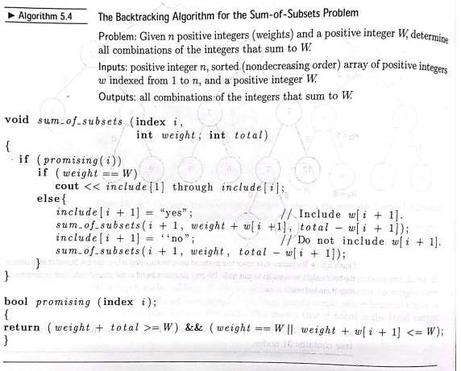

(Karachi Campus)

*Department of Software Engineering*

**Assignment #02– Spring 2022**

|  |  |  |  |
| --- | --- | --- | --- |
| COURSE TITLE: | **D&AA** | COURSE CODE: | **CSC-321** |
| Class: | **BSE 4** | Shift: | **Morning** |
| Course Instructor: | **ENGR. BUSHRA FAZAL KHAN** | Assignment Date: | **24-May-2022** |
| Max. Marks: | **4 Points** | Assignment Due: | **31-May-2022** |

Psudo-code for backtracking algorithm of Sum of subset problem is given below. Explain the mechanism for given data

n=4, W=13, and w1=3, w2=4, w3=5, w4=6

